Resilient South Heatwave Hypothetical
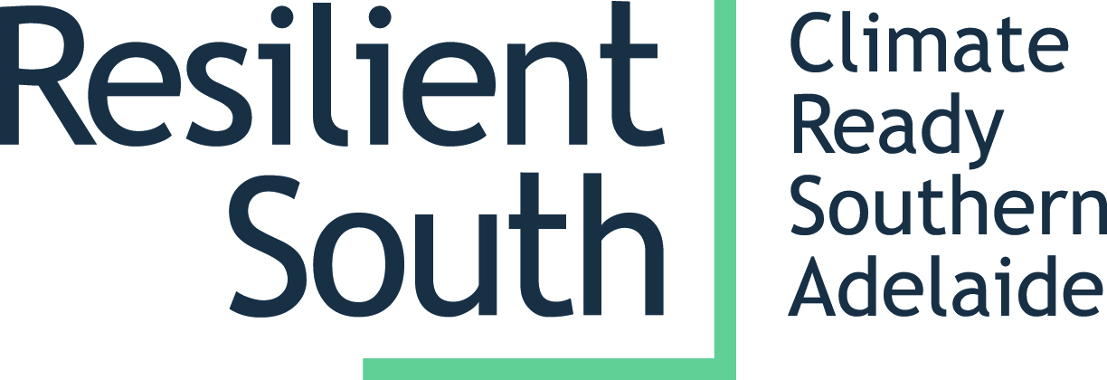
6:30 – 9:00pm, Wednesday 7 February 2018
Marion Cultural Centre

Background
Resilient South is a partnership between four councils in southern Adelaide (Cities of Onkaparinga, Marion, Holdfast Bay and Mitcham), the AMLR NRM Board and the State Government. The partners have worked together for many years to develop a regional climate change adaptation plan involving extensive community engagement; an assessment of climate change risks; and identification of vulnerable communities, businesses and natural environments. We are now working regionally and also at an individual council level to respond to these risks.

The Hypothetical
On the evening of Wednesday 7 February 2018, Resilient South will host a Heatwave Hypothetical at Marion Cultural Centre (seating 280pp). Extended heatwaves are a major climate change risk and they're getting worse. Impacts include high death rates and hospital admissions amongst the elderly, homeless and very young; compromised infrastructure (think buckling train lines and melting bitumen); pressure on energy supplies, bushfire, and on it goes… There are many services available to support the vulnerable and there are also actions that individuals and organisations can take to reduce their exposure and vulnerability.

The Hypothetical involves a skilled facilitator (Amanda Blair) setting the scene around a heatwave scenario in 2025. A series of panellists respond and include representatives from the police, fire and emergency services, red-cross, energy providers, homelessness services, schools, local government, natural resource managers, hospitals, ABC local radio etc. The facilitator takes the panel through the course of an extended heatwave and asks targeted questions to elicit responses to specific challenges. New, more daunting challenges emerge as the heatwave progresses through the seven days.

Beyond the benefits to the community, who will learn ways to improve their resilience; there will also be benefits in a broad range of professional sectors working together on the challenges presented in the scenario. Panellists will have a unique opportunity to problem solve collaboratively, highlighting the areas we are currently doing well and those requiring further work. This experience is designed to strengthen professional working relationships and foster future collaborative work.

Purpose/Desired Outcomes
- Target attendance – 200 people
- Engage community members in a lively, fun and interactive conversation about heatwaves, including available services and options for getting prepared
- Build community knowledge and capacity around responding to the impacts of climate change
- Connect service providers with each other and strengthen working relationships
- Celebrate the good work already being done and continue the ongoing conversation about how to address challenges
- Provide an opportunity for showing what best practice might look like when we have it all sorted out in 2025 (!)

